Dimensionality Reduction in High-Dimensional Synthetic Data: A Comparative Study of PCA and t-SNE
Student: Sai Krishna Nallavula (24083295)
GitHub Repository link: https://github.com/saikrishnanallavula/Machine-Learning-Tutorial

1. Introduction
Datasets with a high number of dimensions have also become the hallmark of modern data science, ranging from the fields of bioinformatics, finance, image representations, and sensor readings. Even though machine learning algorithms can handle these datasets with high dimensions, the understandability of the data is not feasible without reducing them into lower-dimensional representations. This particular project also aims to address the issue of dimensionality reduction, which is a crucial technique used for reducing high-dimensional data spaces into 2D or 3D representations.
Of the various approaches used for this, the two most widely used are PCA and t-SNE. PCA is a traditional technique that finds the orthogonal axes that correspond to the major directions of the data, and hence it is very efficient and easy to understand (Jolliffe, 2002). t-SNE, on the other hand, is a technique that is designed specifically for the visualization of complex datasets that lie on a higher-dimensional manifold, and it preserves the local structure of the data (van der Maaten & Hinton, 2008).
For this analysis, I processed a 50-dimensional synthetic dataset with four distinct clusters. The primary goal was to explore the properties of PCA and t-SNE when used for data that lies in a higher number of dimensions, where it contains a mixture of linear patterns and Gaussian correlations. I sought not only to create these visualization charts but also to assess their quality quantitatively using the silhouette score for both PCA and t-SNE.
Surprising results emerge from the analysis. PCA, contrary to t-SNE's popularity for creating aesthetic embeddings, unexpectedly performed better on the separation of clusters than t-SNE, indicating the importance of high-dimensional data structure for the choice of the appropriate technique for reducing said data.
2. Dataset Description
The data used for the project was completely synthetic and had controlled structure for clusters. This gave the data 1600 samples, with 50 features that were continuous, ranging from f1 to f50, along with a column for the class label, which indicated the four classes. This was clear by the shape of the data shown in the notebook:
All feature columns were of type float64, and no missing values were present, which simplified the preprocessing workflow and allowed a direct focus on dimensionality reduction.
To validate that all four classes were evenly represented, I plotted the class distribution. Each class (0, 1, 2 and 3) contained exactly 400 samples, confirming that the dataset was balanced.
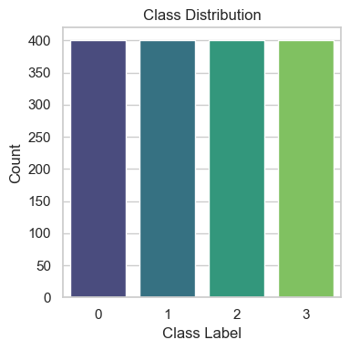
Figure 1 Class distribution bar chart.
The data was generated using distinct Gaussian clusters with varying means along the 50 dimensions. This acted as a measure that helped provide distinct class boundaries, at the same time revealing the relationship between the features. The high degree of multicollinearity that existed later, when the correlation heatmap was produced, was not unexpected.
By using a synthetic dataset for this project, I was assured that there were no ethical considerations involved. More importantly, I was also able to examine the behavior of PCA and t-SNE independently of the typical patterns of noise that are seen when using real datasets. This allowed me to examine how a dataset with well-separated clusters of high dimension works for the purposes of dimensionality reduction.
3. Exploratory Data Analysis
However, before the use of dimensionality reduction, it was essential that I developed some insight into how the features were distributed on their own and together. I started by examining the relationship between a group of features: (f1, f2, f3). This helped me understand that the four classes were already separated in the raw space of the features.
What the plot brought out was that there were four compact and distinct clouds of data points, each of which belonged to one of the classes. For example, class 0 was concentrated in lower ranges of f1 and f2, while class 3 was higher on f1 and f2.
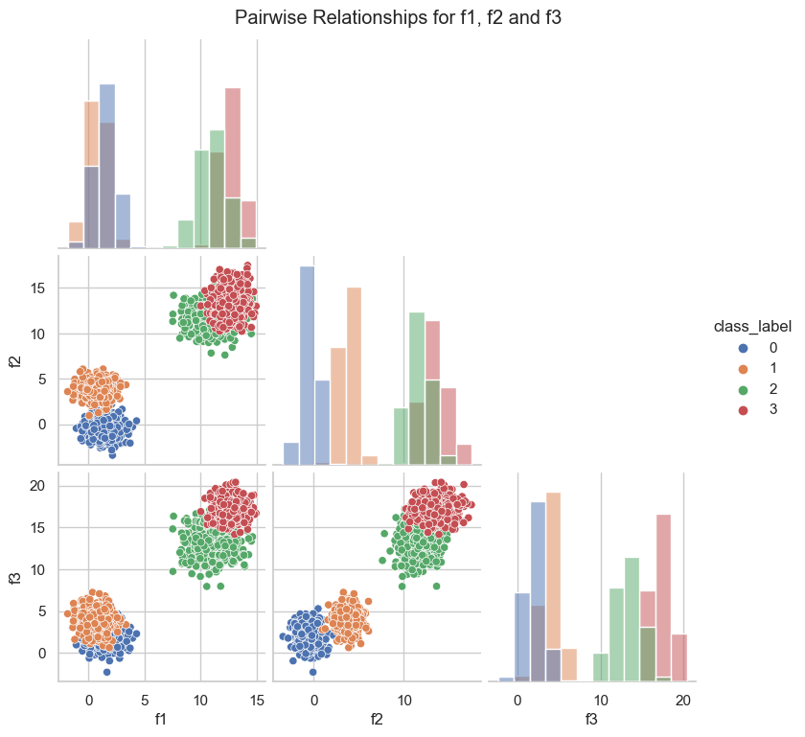
Figure 2 Pairwise relationships for f1, f2, f3
The next step was analysing feature correlations. When I created a heatmap of correlations for the first 15 features, a striking pattern appeared: correlations between most feature pairs were extremely high, often between 0.75 and 0.97.
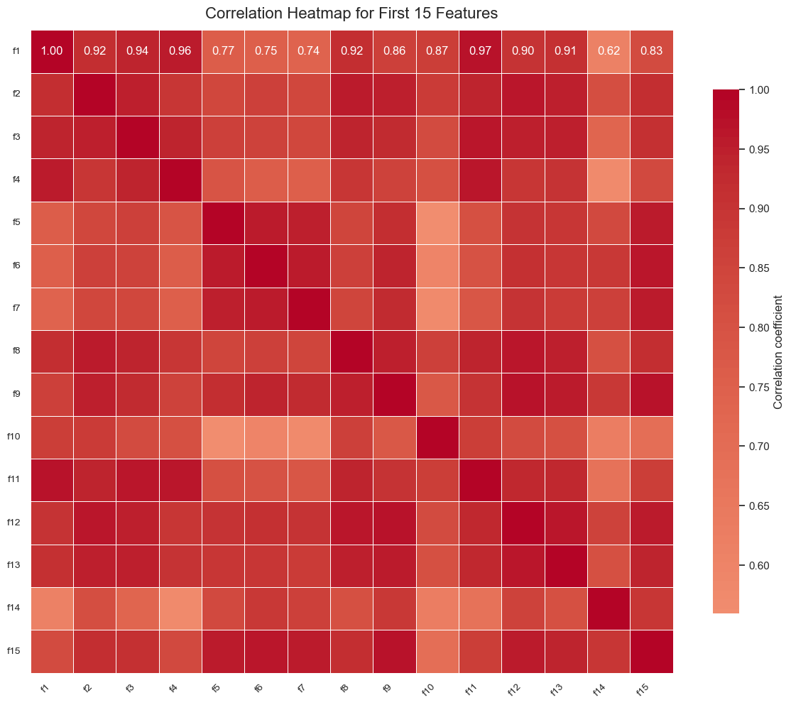
Figure 3 Correlation heatmap for first 15 features
This indicated that there was a strong multicollinearity among features, meaning that many of the features were not contributing unique information. Theoretically, PCA should work very well on these data because it reduces several redundant features into a handful of principal components that retain nearly the same data variability (Jolliffe, 2002).
This initial analysis, then, identified two expectations: PCA would probably capture the variability of the data using only a handful of components, and t-SNE would probably produce clusters that are highly compact in the embedded space because of the distinct separations that already existed.
4. Principal Component Analysis (PCA)
4.1 Mathematical Foundation
PCA operates by transforming the original feature space into a new basis defined by eigenvectors of the covariance matrix. If $X$is the standardised data matrix, PCA computes the covariance matrix:
$$Σ=\frac{1}{n-1}X^{⊤}X$$
Then it solves the eigenvalue problem:
$$Σw_{k}=λ_{k}w_{k}$$
where $w_{k}$are eigenvectors and $λ_{k}$represent the proportion of variance explained by each principal component. The principal components are ordered such that $λ_{1}≥λ_{2}≥...$, meaning the first few components capture most of the structure in the data.
4.2 Scree Plot and Variance Explained
The scree plot was very informative about the variation explained by the 50 components. PCA analysis indicated that the variation explained by the first principal component was about 86% of the total variation, with the second contributing about 6% of the total variation. From the third or fourth components, the variation becomes negligible.
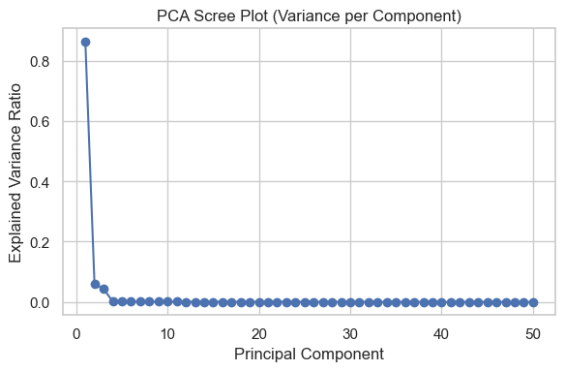
Figure 4 PCA Scree plot.
The cumulative variance plot reinforced this finding. The first two components together explained roughly 92–93% of the total variance. By the time we reached the first three components, the cumulative explained variance had exceeded 96%.
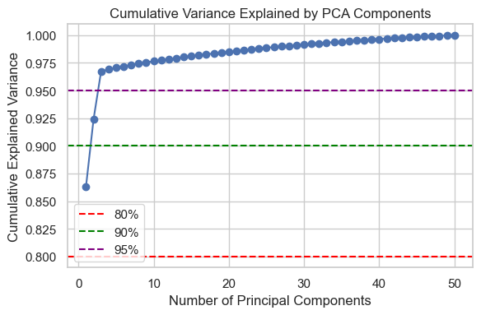
Figure 5 Cumulative variance explained.
These results strongly confirmed our expectation from the correlation analysis: redundancy in the high-dimensional features caused PCA to compress the dataset extremely efficiently.
4.3 PCA 2D Projection
The PCA projection plot showed a clear and almost perfect separation of the four classes. Each class appeared as a distinct cluster with minimal overlap. For example:
- Class 0 centred around PC1 ≈ −9
- Class 1 near PC1 ≈ −3
- Class 2 around PC1 ≈ 3
- Class 3 near PC1 ≈ 8.5
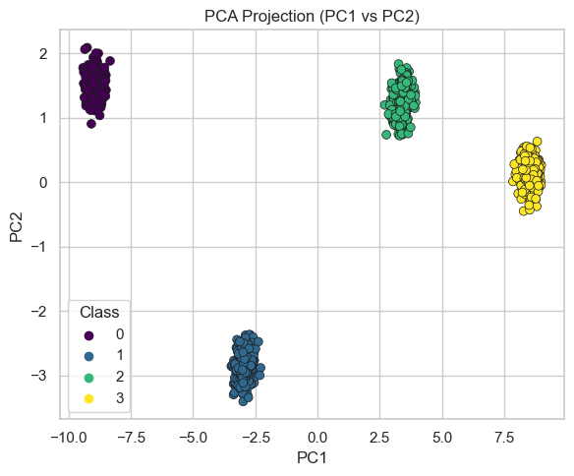
Figure 6 PCA PC1 vs PC2 projection.
The silhouette score for PCA’s 2D embedding was 0.9444, the highest among all dimensionality reduction methods evaluated. This score indicates extremely strong separation between clusters, meaning PCA captured the essential geometry of the data almost perfectly.

5. t-SNE Analysis
5.1 Method Overview
Unlike PCA, which uses a linear transformation, t-SNE models the pairwise similarity between points in high-dimensional space using Gaussian kernels and attempts to preserve these similarities in a low-dimensional space using a Student-t distribution. The algorithm optimises the Kullback–Leibler divergence:
$$KL(P∥Q)$$
where $P$and $Q$represent high-dimensional and low-dimensional similarity distributions respectively (van der Maaten & Hinton, 2008).
This method pays more attention to local neighbourhoods and is especially powerful when the dataset contains curved manifolds or nonlinear clusters.
5.2 t-SNE Embeddings
I generated t-SNE embeddings for two perplexity values: 30 and 50. Both embeddings produced very tight and visually appealing clusters. Each of the four classes formed its own dense region in the plot, distinctly separated from the others.
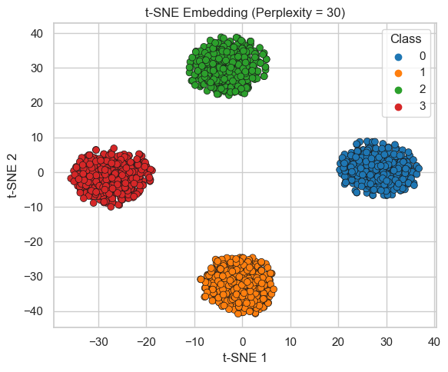
Figure 7 t-SNE (perplexity = 30).
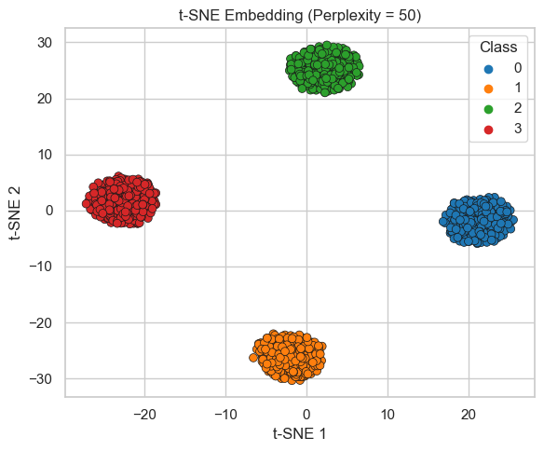
Figure 8 t-SNE (perplexity = 50).
There were minor differences in the arrangement of clusters with respect to each other, which is a known issue with t-SNE. Perplexity 50 used more evenly spaced points and had a better silhouette score, indicating that it better characterized the neighborhood around the points.
Although the t-SNE results had excellent visualization qualities, the silhouette indexes for t-SNE were 0.8317 (perplexity of 30) and 0.8953 (perplexity of 50). Both of these were
6. Quantitative Comparison Using Silhouette Scores
To objectively compare PCA and t-SNE, I computed silhouette scores for each low-dimensional embedding. The results were:
Method | Silhouette Score
PCA (PC1–PC2) | 0.9444
t-SNE (p=30) | 0.8317
t-SNE (p=50) | 0.8953
This analysis brings out an important fact. PCA, despite being less efficient than t-SNE for visualization, ended up performing better than t-SNE. This fact is also related to the nature of the data. The clusters of data used in this synthetic study were linearly separable and also highly correlated. Thus, PCA was almost optimal for reducing the space. t-SNE also performed well, but since it was nonlinear, it caused a slight loss of compactness of the clusters compared to PCA.
These results echo a commonly overlooked consideration when performing dimensionality reduction: there is no universally better technique. The quality of the embedding approach depends on the geometry of the data.
7. Discussion
Analyzing the results, it is easy to understand why PCA performed better than t-SNE, although the latter is renowned for its visualization capability. This is because the data used for the project consists of well-behaved Gaussian clusters that are linearly separated. This suits PCA because it works well when it identifies the vectors of maximum variation that align well with the class separation. The outstanding silhouette value reveals that PCA maintained the data clusters with less distortion.
t-SNE, although very potent, works differently. It is strictly designed for the preservation of local neighborhoods, not global distances. For datasets that already have good linear separability, the transformation carried out by t-SNE will actually make the geometry a bit complex, causing the lower silhouette score compared with PCA.
This comparison also illustrates a very important practical takeaway. In the presence of structured, multivariate data that is at least somewhat linear or well-correlated, PCA can not only do the job, it can do it better. t-SNE will only correctly apply when the data is nonlinear, with curved manifolds or overlapping clusters that PCA cannot disentangle.
8. Limitations and Future Work
Even though the analysis yielded very distinctive patterns, there are several limitations that need to be taken into account. Firstly, the data used was synthetic, and this implies that the data used was cleaner and separable compared to real data, which often contains noise, overlapping boundaries, and missing data.
Only the 2D embeddings were analyzed. It is possible that the 3D representations could reveal more details, and that not only the silhouette score but other parameters, like Davies-Bouldin, could also be used for the analysis.
The hyperparameters of the t-SNE algorithm were not heavily tuned. Learning rate, for example, or early exaggeration could also affect the results. Lastly, other contemporary approaches on the reduction of dimensions, for example, UMAP, can provide deeper insights and should also be explored for the extended version of the project.
9. Reproducibility and GitHub Setup
To ensure that this project is reproducible, the project will ensure that the Jupyter notebook is saved with the following filename: 24083295_PCA_tSNE_Analysis.ipynb. Every generated figure should also be exported to a designated figures/ folder. Additionally, the project will ensure that the respective placeholders used in the report are used. The project will also include a requirements.txt file that contains the following essential libraries that will be used throughout the project: NumPy, Pandas, Matplotlib, Seaborn, and scikit-learn. This project will also include the data within the data/ folder. However, since the data will not require external sources, the data will also be generated within the project.

10. Conclusion
This particular project allowed for the examination of dimensionality reduction strategies on high-dimensional synthetic data. The performance of PCA was exceptional, where it retained the data’s variability of over 90% with only the first two components. PCA also obtained the highest silhouette value for the data. t-SNE identified interesting patterns on the data plot, where it indicated that it is not necessarily the case that the results of the nonlinear approaches are better than those of the linear approaches, provided the underlying structure of the data is already linear.
These results support a sound practical guideline for the use of PCA and t-SNE: the choice between PCA and t-SNE should depend on the geometry of the data, not on convention. PCA is still a very useful baseline method, and t-SNE continues to be a indispensable tool for discovering nonlinear patterns when they are actually present.
References
Jolliffe, I.T. (2002) Principal Component Analysis. Springer.
van der Maaten, L. & Hinton, G. (2008) ‘Visualizing Data using t-SNE’, Journal of Machine Learning Research, 9, pp. 2579–2605.
Goodfellow, I., Bengio, Y. & Courville, A. (2016) Deep Learning. MIT Press.

